

**UGANDA INSTITUTE OF INFORMATION AND COMMUNICATION TECHNOLOGY**

**FINAL YEAR PROJECT REPORT**

**A TELE MEDICINE PLATFORM DESIGNED TO CONNECT PATIENTS WITH LICENSED MEDICAL PROFFESSIONALS THROUGH SECURE CONSULTATIONS.**

**MEDICAL SERVICE (TELE-DOC)**

**BY.**

|  |  |
| --- | --- |
| **STUDENTS’ NAMES** | **REGISTRATION NUMBER** |
| NAKIRAGWA LETICIA NAKITY | 2023/ITB/DAY/1706/G |
| LUBWAMA MARVIN ESUKA | 2023/ITB/DAY/0632 |
| MARACTHO JOHN BOSCO | 2023/ITB/DAY/1005 |
| KIKULE AUGUSTINE | 2023/ITB/DAY/1365 |
| LEPI DENISH | 2023/ITB/DAY/0628 |
| KAPERE INNOCENT | 2023/ITB/DAY/0939 |

PROJECT CODE: No.22

DEPARTMENT OF ICT AND ENGINEERING

SUPERVISOR:

MR. NKURUNGI EDISON

PROJECT REPORT SUBMITTED TO THE DEPARTMENT OF ICT IN PARTIAL FULFILLMENT OF THE REQUIREMENTS FOR THE AWARD OF A DIPLOMA IN INFORMATION TECHNOLOGY FOR BUSINESS AT UGANDA INSTITUTE OF INFORMATION AND COMMUNICATION TECHNOLOGY.

**MAY, 2025**

**ABSTRACT**

Telemedicine has transformed healthcare delivery, enabling patients to access medical services remotely through digital platforms. This telemedicine platform is designed to bridge the gap between patients and licensed medical professionals, ensuring secure and efficient consultations. By leveraging advanced technology, the platform facilitates real-time communication through messaging, and electronic health records, allowing patients to receive diagnoses, prescriptions, and medical advice without the need for physical visits.

Security and confidentiality are at the forefront of the platform's design, incorporating encrypted communication channels and stringent data protection measures to safeguard patient information. The system ensures compliance with healthcare regulations, making it a reliable and trusted option for both patients and providers.

With features such as appointment scheduling, digital prescriptions, and remote monitoring, the platform enhances accessibility to healthcare, particularly for individuals in underserved or remote areas. It fosters convenience, reduces wait times, and minimizes healthcare costs, making quality medical care more inclusive.

By integrating telemedicine into mainstream healthcare, this platform promotes patient-centered care while empowering medical professionals to extend their expertise beyond geographical constraints. Its user-friendly interface and seamless experience redefine modern healthcare, ensuring that essential medical support is available anytime, anywhere.

# **DECLARATION**

We Nakiragwa Leticia Annity , Lubwama Marvin Esuka, Maractho John Bosco,Kikule Augustine, Lepi Denish, Kapere Innocent, hereby assert that this project report is unique and has been done by ourselves with the help of our supervisor Mr. Nkurungi Edison has not been submitted for any other diploma award and effort will be that it will never be reproduced.

|  |  |  |
| --- | --- | --- |
| **STUDENTS’ NAMES** | **REGISTRATION NUMBER** | **SIGNATURE** |
| NAKIRAGWA LETICIA NAKITY | 2023/ITB/DAY/1706/G |  |
| LUBWAMA MARVIN ESUKA | 2023/ITB/DAY/0632 |  |
| MARACTHO JOHN BOSCO | 2023/ITB/DAY/1005 |  |
| KIKULE AUGUSTINE | 2023/ITB/DAY/1365 |  |
| LEPI DENISH | 2023/ITB/DAY/0628 |  |
| KAPERE INNOCENT | 2023/ITB/DAY/0939 |  |

# **APPROVAL**

This is to certify that this project report has been done by Nakiragwa Leticia Nakity , Lubwama Marvin Esuka, Maractho John Bosco,Kikule Augustine, Lepi Denish, Kapere Innocent of registration numbers 2023/ITB/DAY/1706/G,2023/ITB/DAY/0632,2023/ITB/DAY/1005,2023/ITB/DAY/1365,2023/ITB/DAY/0628,2023/ITB/DAY/0939. The proposal has been presented in accordance with the guideline governing the award of Diploma in Information Technology for Business at Uganda Institute of Information and Communications Technology (UICT).

Mr. NKURUNGI EDISON ..………………… …………………

**Supervisor Signature Date**

# 

# **ACKNOWLEDGEMENTS**

We, the members of Group 22, would like to extend our sincere appreciation to our supervisor, Mr. Nkurungi Edison (NE**)**, for his invaluable guidance, encouragement, and support throughout the development of this project proposal. His expertise and mentorship have been instrumental in shaping our ideas and bringing this project to life.

We also wish to thank the lecturers and the entire administration of Uganda Institute of Information and Communications Technology for cultivating a conducive learning environment and promoting student projects. Their support and belief in our abilities have been a constant source of motivation.

Thank you all for your contributions to our growth and success.

# **LIST ACRONYMS**

UICT =Uganda Institute of information and communication Technology.

DFD-Data Flow Diagram

ER-Entity Relationship

UI/UX - User-Centered Interface and User Experience.

**TABLE OF CONTENT**

ABSTRACT ii

DECLARATION i

APPROVAL ii

ACKNOWLEDGEMENTS iii

LIST ACRONYMS iv

1.0 CHAPTER ONE: INTRODUCTION 1

1.1 INTRODUCTION 1

1.2 BACKGROUND 1

1.3 PROBLEM STATEMENT. 1

1.4 GENERAL OBJECTIVE 1

1.5 SPECIFIC OBJECTIVES 2

1.6 SCOPE OF STUDY 2

1.6.1 TIME SCOPE 2

1.6.2 GEOGRAPHICAL SCOPE 2

1.6.4 TECHNICAL SCOPE 2

1.7 SIGNIFICANCE 2

1.7.1 MANAGEMENT 2

1.7.2 USERS 2

1.7.3 GENERAL PUBLIC 2

1.7.4 RESEARCHERS 3

1.8 JUSTIFICATION 3

1.8.1 CONVICTION 3

2.0 CHAPTER TWO: LITERATURE REVIEW 4

2.1 INTRODUCTION 4

2.2 STATE OF PRACTICE (STATE OF CURRENT AFFAIRS) 4

2.3 STATE OF ART SIMILAR EXISTING SYSTEMS. 4

2.4 COMPARATIVE EVALUATION 4

3.0 CHAPTER THREE: METHODOLOGY 5

3.1 INTRODUCTION 5

3.2 SYSTEM STUDY 5

3.2.1 INTERVIEWS 5

3.2.2 OBSERVATIONS 6

3.2.3 DOCUMENT REVIEW 6

3.3 SYSTEM ANALYSIS 6

3.3.1 USE-CASE DIAGRAMS 6

3.3.2 FLOW CHARTS 6

3.3.3 DECISION TREES 6

3.3.4 DICTIONARY TABLES 6

3.4 SYSTEM DESIGN 6

3.4.1 DATA FLOW DIAGRAM (DFD) 6

3.4.2 ENTITY RELATIONSHIP (ER) 7

3.5 SYSTEM DEVELOPMENT. 7

3.5.1 FRONT-END TOOLS 7

3.5.2 BACK-END TOOLS 7

3.6 SYSTEM TESTING AND VALIDATION 7

3.6.1 UNIT TESTING 7

3.6.3 USER ACCEPTANCE TEST 7

4.0 CHAPTER FOUR: SYSTEM STUDY, ANALYSIS AND DESIGN 9

5.0 CHAPTER FIVE: SYSTEM DEVELOPMENT, TESTING AND VALIDATION 20

5.1 SYSTEM INTERFACES (DEVELOPMENT) 20

5.1.1 Hardware tools 20

5.1.2 Software tools were divided into two: 20

5.2 SYSTEM TESTING 23

5.2.1 Unit testing 23

5.2.2 Integration testing 23

6.0 DISCUSSION, CONCLUSION AND RECOMMENDATIONS 24

REFERENCES: 26

APPENDICES 27

APPENDIX I: 27

Appendix II: Budget for Tele-Doc Project Proposal. 28

Appendix III: Questionnaire 29

# 

# **1.0 CHAPTER ONE: INTRODUCTION**

**1.1 INTRODUCTION**

In today’s fast-paced world, accessing quality healthcare services can be a daunting task, especially for those living in remote or underserved areas. The traditional model of healthcare delivery often requires patients to travel long distances, wait in queues, and spend variable time and resources. Tele-Doc aims to bridge this gap by leveraging Telemedicine technology to provide convenient, affordable, and high-quality healthcare services to patients anywhere, any time. The Tele-Doc platform will connect patients with licensed healthcare professionals through secure text consultations, enabling remote diagnosis, treatment, and monitoring. By harnessing the power of telemedicine, Tele-Doc seeks to improve health outcomes, enhance patient satisfaction, and reduce healthcare costs. The project outlines the visions, objectives, and key components of the Tele-Doc platform, highlighting its potential to transform the healthcare landscape.

**1.2 BACKGROUND**

The rapid advancement of technology as revolutionized various sectors, and healthcare is no exception. The traditional healthcare models, often characterized by physical clinic visits, are increasingly becoming less efficient and accessible. This particularly true for individuals residing in remote areas, those with mobility limitations, and those with busy schedules. Telemedicine, the delivery of health care services through telecommunication technologies, offers a promising solution to those challenges.

* 1. **PROBLEM STATEMENT.**

Limited access to quality healthcare: Many individuals, especially in rural and underserved areas, face significant barriers to accessing quality healthcare services, Healthcare costs: The cost of healthcare services, including transportation and time off work, can be prohibitive for many.

## **1.4 GENERAL OBJECTIVE**

The general objective of this project was designed to Improve access to healthcare by providing remote access to healthcare services, enhance patient satisfaction by Offering flexible and patient centered care hence reducing wait times and to reduce healthcare costs by Minimizing healthcare expenditures by reducing the need for in person visit and hospitalizations.

### **1.5 SPECIFIC OBJECTIVES**

1.5.1 To study analyze the current system used.

1.5.2 To identify requirements necessary for designing an online doctor-patient interactions system.

1.5.3 To design and develop a user-friendly online platform for managing patient records.

## **1.6 SCOPE OF STUDY**

The system deals with medical health care services offered by Ruby in Kampala.

### **1.6.1 TIME SCOPE**

Project timeline: The project is expected to be completed within one year (12 months)

### **1.6.2 GEOGRAPHICAL SCOPE**

The system was built for use by the people in the rural areas of Uganda.

### **1.6.4 TECHNICAL SCOPE**

The system interface was created with user-friendly features and Tele-Doc will provide real-time consultations between patients and healthcare professionals. The system will be connected to the cloud to store data (e.g., menus, messages) and could be retrieved anywhere at any time.

* 1. **SIGNIFICANCE**

### **1.7.1 MANAGEMENT**

The “Tele-doc” system helps health professionals to track appointments and schedules, manage consultations and enable make appropriate decisions for efficient service delivery. .

### **1.7.2 USERS**

The system makes it easy for patients to log in and find information on available medical services at any time.

### **1.7.3 GENERAL PUBLIC**

The system benefits the general public by providing a platform for consumers to consult, s making it easier to find reliable and quality services.

### **1.7.4 RESEARCHERS**

The system will help future researchers to discover system functionalities and use it in their work to improve or develop a system that may be of better use or for system integrations.

* 1. **JUSTIFICATION**

### **1.8.1 CONVICTION**

Every medical platform has a unique menu and service style, which can be presented to consumers through “Tele-Doc”. Consumers makes informed decisions and finds the best medical services meeting their needs, increasing customer satisfaction and trust in the health sector.

# 

# **2.0 CHAPTER TWO: LITERATURE REVIEW**

## **2.1 INTRODUCTION**

## This chapter provides an overview of the current state of practice and art in the Telemedicine, focusing on e-commerce platform systems.

## **2.2 STATE OF PRACTICE (STATE OF CURRENT AFFAIRS)**

Tele-doc services let people talk to doctors remotely using phones, apps, or video calls. They help with common illnesses, mental health, and managing long-term conditions. These services are growing fast, especially in cities, and often connect with health records and pharmacies. But in rural areas, poor internet and low-tech access are still big challenges. Rules and insurance support are improving, and new tools like health wearables and smart apps are making care even easier.

## **2.3 STATE OF ART SIMILAR EXISTING SYSTEMS.**

### Recently telemedicine platforms have provided virtual consultations, prescription management, and mental health support. Similar systems have been developed such as MDLive, Amwell, plushcare. However, Tele-Doc project is to enable Internet of Thinks (IoT) which integrates with wearable devices and IoT devices to enable remote monitoring and tracking.

## **2.4 COMPARATIVE EVALUATION**

|  |  |  |  |  |  |  |  |  |  |
| --- | --- | --- | --- | --- | --- | --- | --- | --- | --- |
| **System type** |  | | |  | |  | |  | |
| **Features** | **Functionality** | **Cost** | | **Quality** | | **Customer support** | | **Security.** | | **Integration with wearable devices.** |
| Teladoc | YES | YES | YES | | YES | | YES | | YES | | NO |
| American well | NO | NO | YES | | NO | | NO | | NO | | NO |
| MDLive | YES | YES | YES | | YES | | YES | | YES | | NO |
| Tele-Doc | YES | YES | YES | | YES | | YES | | YES | | YES |

# 

# **3.0 CHAPTER THREE: METHODOLOGY**

## **3.1 INTRODUCTION**

In this chapter, outlines the tools, methods, and techniques we used to achieve the specific objectives of the Tele-Doc project.

## **3.2 SYSTEM STUDY**

To gather requirements for the proposed system, we employed the following methods:

## **3.2.1 INTERVIEWS**

We conducted interviews with patients in the hospital and health experts in Kampala to gather information on their needs, preferences, and experiences. These interviews provided firsthand information and helped us diversify our data collection.

## **3.2.2 OBSERVATIONS**

We observed the current operations of health care service providers in Kampala, including their consultation processes, and patients’ interactions with doctors. These observations provided factual information for system development.

## **3.2.3 DOCUMENT REVIEW**

We thoroughly reviewed existing documents, such as reports, books and patients’ feedback, to identify requirements and challenges in the current system.

## **3.3 SYSTEM ANALYSIS**

### **3.3.1 USE-CASE DIAGRAMS**

We used use-case diagrams to describe the system's functionality, scope, and user interactions. These diagrams helped us identify the requirements and constraints of the system.

### **3.3.2 FLOW CHARTS**

We used flow charts to depict the system process, breaking down the system into step-by-step processes.

### **3.3.3 DECISION TREES**

We used decision trees to show the system’s hierarchical structure and organizational classification, aiding in decision-making.

### **3.3.4 DICTIONARY TABLES**

We used dictionary tables to describe the detailed properties of the database elements of the system.

## **3.4 SYSTEM DESIGN**

We used the following methods to design the system:

### **3.4.1 DATA FLOW DIAGRAM (DFD)**

We employed Data Flow Diagram (DFD) technique to express the system requirements, showing data flow between various functions of the system and specifying how the system was implemented.

### **3.4.2** **ENTITY RELATIONSHIP (ER)**

We used an Entity Relationship (ER) diagram to collect, store, and retrieve data used by the system for its functionality.

## **3.5 SYSTEM DEVELOPMENT.**

The development of Tele-Doc involved:

### **3.5.1 FRONT-END TOOLS**

- HTML for creating online web pages

- CSS for styling the presentation of web pages

- JavaScript for creating interactive features

-

### **3.5.2 BACK-END TOOLS**

- Firebase-provides a comprehensive set of tools which helps to manage, scale web and mobile applications quickly without managing servers.

## **3.6 SYSTEM TESTING AND VALIDATION**

### **3.6.1 UNIT TESTING**

The system was tested to ensure it produced the intended results, such as feedback.

### **3.6.2 SYSTEM TESTING**

### The system was tested as a whole to ensure the integrity of the data flow checks within the system.

### **3.6.3 USER ACCEPTANCE TEST**

In order to ensure that Tele-Doc met the needs and requirements of Telemedicine service companies and consumers in Kampala, we conducted a user acceptance test. This test involved active participation from the intended users of the system, who provided feedback on the system’s functionality and usability.

# 

# 

# **4.0 CHAPTER FOUR: SYSTEM STUDY, ANALYSIS AND DESIGN**

**4.1 SYSTEM STUDY**

We employed various data collection techniques, such as observation, questionnaires/interviews, to comprehensively investigate the existing Telemedicine service companies’ systems. We found that the current method of operation relied on manual order catalogues, where patients visited hospitals to order services based on available options.

**4.1.1 MANUAL ORDER CATALOGUE.**

We discovered that patients made decisions based on the manual order catalogue which sometimes led to disappointment when their chosen medical experts are unavailable. Appointments were placed on paper, and taken for review.

**4.1.2 AN E-COMMERCE WEBSITE PLATFORM.**

The information from the research showed that this system is currently unrevealed to external health care centers in Kampala; the system also allows individuals to make appointments and online consultations from health care service centers.

**4.1.3 STRENGTH OF EXISTING SYSTEM**

The following were identified strengths for the present systems.

the existing systems Teladoc and American well, have strengths in connecting patients with medical professionals, offering various options, ensuring efficient booking, facilitating communication and transactions between parties, whereby providing a platform for patients to find and book services and for health associated businesses to showcase and manage their services.

**4.1.4 WEAKNESS OF THE EXISTING SYSTEM.**

The existing systems have weaknesses in their limited functionality, including restricted location options, lack of direct communication, inadequate filtering and search capabilities, poor website design, absence of review and rating systems, and insufficient customer support, ultimately hindering user experience and overall effectiveness.

**4.1.5 DATA COLLECTION.**

We conducted our research, predominantly using questionnaires to collect necessary information from the field. Questionnaires were distributed to users. We categorized our respondents based on occupation and location/income levels. The purpose of this activity was to solicit user requirements, which was necessary to design and implement an e-commerce website platform.

**This section presents the data collected through the questionnaire.**

**Administration and return of questionnaire**

|  |  |  |
| --- | --- | --- |
| **Questionnaire** | **Total** | **Percentage (%)** |
| Administered | 50 | 100 |
| Returned | 21 | 70 |
| Not returned | 29 | 30 |
| Total | 50 | 100 |

From the above table, a total number of 50 questionnaires were given out, 21 were returned, and 29 were not returned.

**Frequency distributions of respondents according to occupation.**

|  |  |  |
| --- | --- | --- |
| **Occupation.** | **Respondents** | **Percentage (%)** |
| Event planners/consumers. | 39 | 63 |
| Catering service providers | 11 | 37 |
| Total | 50 | 100 |

From the table above, 60% of the respondents were medical experts, while 40% were Health care service providers.

Table 1.3: **Frequency Distributions of Respondents According to Location/Income Levels.**

|  |  |  |
| --- | --- | --- |
| **Location, Kampala-Specifically.** | **Respondents** | **Percentage (%)** |
| Urban areas/higher income levels. | 33 | 60 |
| Rural areas/lower income levels. | 15 | 40 |
| Total | 50 | 100 |

From the table above, 60% of the respondents were in the brackets of urban areas, 40% were with in rural areas.

**Table 1.5: Patients View On Tele-Doc.**

|  |  |  |  |  |  |  |
| --- | --- | --- | --- | --- | --- | --- |
| **Questions** | **No.**  **Of**  **YES** | **No.**  **Of**  **NO** | **%**  **Of**  **YES** | **%**  **Of**  **NO** | **Total** | **Total %** |
| Are you aware of such an e-commerce website platform? | 11 | 39 | 22 | 78 | 50 | 100 |
| Is ease of navigation important to you on Tele-Doc? | 30 | 20 | 60 | 40 | 50 | 100 |
| Do you prioritize reviews when selecting Health care services? | 26 | 24 | 52 | 48 | 50 | 100 |
| Is a real time communication with health care providers necessary? | 39 | 11 | 78 | 22 | 50 | 100 |
| Do you trust Tele-Doc to ensure quality catering services? | 30 | 20 | 60 | 40 | 50 | 100 |
| Would you recommend Tele-Doc to friends/family? | 27 | 23 | 54 | 46 | 50 | 100 |

From the table above, 78% of the respondents were not aware of such an e-commerce website platform. While only 22% were aware of it. Ease of navigation was important to 60%, while it wasn’t important to 40%. 48% prioritize reviews when selecting health care services, while 50% do not prioritize reviews when selecting health care services. 78% wanted a real time communication with health care service providers necessary, while 22% did not want it. 60% trust Tele-Doc to ensure quality health care services, while 40% did not. Lastly, 54% would recommend Tele-Doc to friends/family.

**4.3 SYSTEM ANALYSIS.**

Our comprehensive analysis of customer requirements, ordering processes, and existing technologies revealed that Tele-Doc was perfectly suited to help health care service providers to expand their services and meet the demands of a growing customer/patient base. The primary objective of the system was to create a user-friendly platform that enabled patients to place appointments and explore various options.

**4.3.1 REQUIREMENTS**

The following requirements were determined for the Tele-Doc system:

**Functional Requirements**

The system implemented the following functional requirements:

Registration: Customers had to register to make an appointment and consultations.

Login: Customers logged into the system by entering their email address and password set during registration.

Place appointment: Customers could make appointments and doctors can either accept or cancel after logging in.

Logout: Customers could log out after consultations and appointments.

**4.3.1.1 OTHER FUNCTIONAL REQUIREMENTS.**

Customers were able to view their appointment details.

**4.3.1.2 NON-FUNCTIONAL REQUIREMENTS**

The system was expected to; Provide secure access to consumers' confidential data,

Provide 24x7 availability; provide better component design to get better performance at peak time, support multiple users at a time, Non-Functional Requirements define system properties and constraints.

The system was Secure, Reliable, Easy to maintain, easily portable due to its small file size, there was room for extension, the system could be re-used for developing other similar systems. It was compatible with windows.

**4.3.2 USE CASE DIAGRAM.**

The Tele-Doc system which is aimed to bridge the gap between health care service companies and consumers in Kampala, Uganda. is illustrated in the following use case diagram, highlighting its functional requirements and actor interactions among consumers, health care companies, and administrators.

**TELE-DOC**

Doctor

Patient

From figure above, the Tele-Doc system, which connects health care service companies with consumers in Kampala, Uganda, illustrated its functionality and user interactions through a use case diagram, detailing how consumers searched and places appointments, viewed profiles , reviewed and rated services, and made secure consultations, while health care companies managed profiles, update services, receive appointments, and interact with consumers, oversee system updates, monitored activities, provided support, analyzed performance, and ensured .

**4.3.3 DATA ANALYSIS**

After collecting and analyzing data, we ensured the accuracy and completeness of the information. We utilized data flow diagrams and system flowcharts to illustrate the system’s functionality and data flow. The system required three distinct flowcharts

**Client-Side System Flowchart**

The customer initiated the system, viewed and browsed available food items, logged in or registered, selected items, and verified whether the correct item had been selected. If not, the customer reset and returned to the selection stage. If the selection was correct, the customer proceeded to confirm the order. Once confirmed, the order was sent to the catering businesses’ system.

Authentication

(Firebase Auth)

user sign up

(patient/doctor)

E-prescription

-Saved to patient profile

-Sent via App/email

Consultation (Messaging)

Profile Creation

-Medical History (Patients)

-Specialization (Doctor)

Data storage (Fire store)

-Appointment Details

-Patient and Doctors records

Follow up

-Health tips/ Results

Appointment Booking

-Date/time section

-Doctor matching

**4.3.4 DECISION TREES.**

A decision tree is a pictorial representation of decision points and corresponding actions based on predefined business rules, and for the Tele-Doc system, it visually illustrates the logical flow of decisions and actions taken by consumers, Health care companies, and administrators, thereby simplifying complex decision-making processes and enhancing system navigation and user experience during its operational phase as shown below.

Start

Patient

Is the Patient Registered?

-Yes → Proceed to Authentication

-No → Register Patient → Proceed to Authentication

Authentication Successful?

-Yes → Proceed to Symptom Assessment

- No → Alert: Authentication Failed → End

Type of Symptoms?

-Physical (e.g., fever, cough, rash)

-Mental Health (e.g., anxiety, depression)

- Chronic Condition Follow-up

Consultation Required?

- Yes → Schedule/Initiate a text

Prescribe Medication?

-Yes → Generate E-Prescription

- No → Recommend Home Remedies / Monitoring

Schedule Follow-Up

-Yes → Book Follow-Up Slot

- No → End Session

-End of Consultation

-Generate visit Patient

**4.3.5 DICTIONARY TABLES.**

| **Field Name** | **Description** | **Data Type** | **Length** | | | **Constraints** | **Example** |
| --- | --- | --- | --- | --- | --- | --- | --- |
| Patient_ID | Unique identifier for the patient | Integer | 10 | | | Primary Key | 1234567890 |
| First_Name | Patient's first name | Varchar | 50 | | | Not Null | John |
| Last_Name | Patient's last name | Varchar | 50 | | | Not Null | Doe |
| Date_of_Birth | Patient's date of birth | Date | - | | | Not Null | 1985-06-15 |
| Gender | Patient's gender | Varchar | 10 | | | Not Null | Male |
| Phone_Number | Patient's contact number | Varchar | 15 | | | Not Null | +256701234567 |
| Email | Patient's email address | Varchar | 100 | | | Unique | [john.doe@example.com](mailto:john.doe@example.com) |
| Address | Patient's residential address | Varchar | 255 | | | Not Null | Plot 123, Kampala, Uganda |
| Emergency_Contact | Name of the emergency contact | Varchar | 100 | | | Not Null | Jane Doe |
| Emergency_Phone | Phone number of the emergency contact | Varchar | 15 | | | Not Null | +256701234568 |
| Consultation_Date | Date of the telemedicine consultation | Date | - | | | Not Null | 2025-05-30 |
| Consultation_Time | Time of the telemedicine consultation | Time | - | | | Not Null | 14:00:00 |
| Consultation_Type | Type of consultation (e.g., First Time, Follow-up, Second Opinion) | Varchar | 50 | | | Not Null | First Time |
| Consultation_Mode | Mode of consultation (e.g., Chat) | Varchar | 50 | | | Not Null | Text |
| Diagnosis | Diagnosis provided | Varchar | 255 | | | Nullable | Hypertension |
|  | during the consultation |  |  | | |  |  |
| Prescription | Prescribed medication or treatment plan | Varchar | 255  Nullable |  | | | Lisinopril 10mg daily |
| Follow_up_Date | Scheduled date for the next consultation | Date | - | | Nullable | | 2025-06-30 |
| Notes | Additional notes from the healthcare provider | Text | - | | | Nullable | Monitor blood pressure |

**4.4SYSTEM DESIGN**

This phase focused on transforming the requirements gathered during the analysis phase into a functional and efficient system design.

**4.4.1 ARCHITECTURAL DESIGN**

The architectural design of Tele- Doc involved the organization of components that constitute the system and the definition of operations guiding its functions. The following tools were utilized for architectural design:

- Data Flow Diagram (DFD) to express system requirements and show data flow between various functions

- Entity Relationship (ER) diagram to collect, store, and retrieve data used by the system.

**4.4.2 DATA FLOW DIAGRAM (DFD)**

The DFD provides a more detailed depiction of data flow throughout the system. It serves as a breakdown of the context diagram, highlighting how raw data moves through the system, is processed, stored in various locations, and managed by different user roles.

Medical records

doctor

**Tele-doc**

patient

**4.4.3 ENTITY RELATIONSHIP DIAGRAM (ERD)**

The ERD illustrates the entities and their relationships within the database, showcasing the data structure and how different data entities are interconnected.

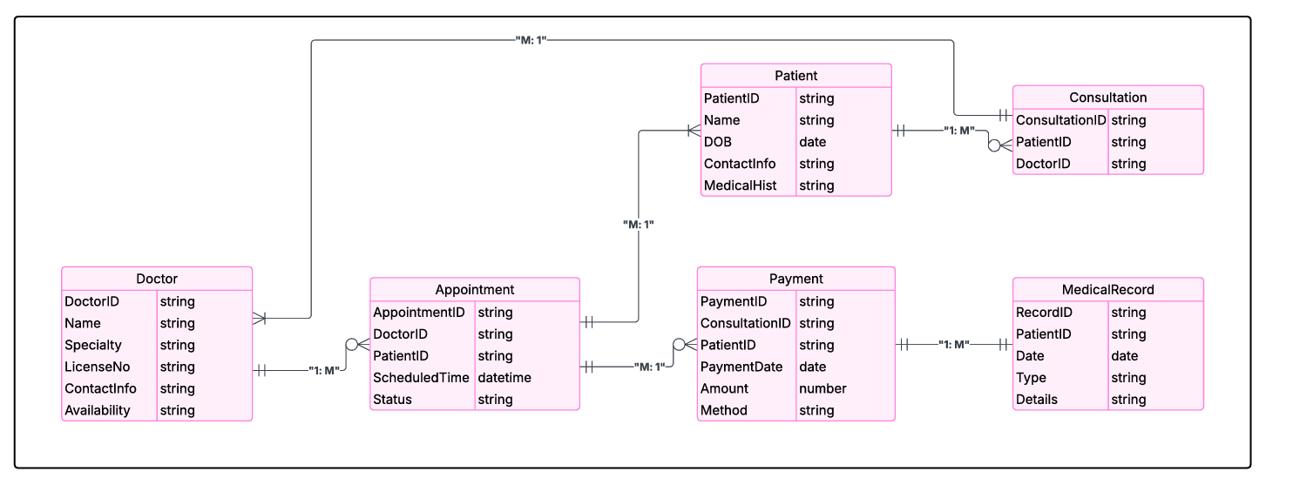

**5.0 CHAPTER FIVE: SYSTEM DEVELOPMENT, TESTING AND VALIDATION**

## **5.1 SYSTEM INTERFACES (DEVELOPMENT)**

During the development of the, we lever Tele-Doc aged several key technologies and tools:

### **5.1.1 Hardware tools**

1. Computers. We used the computers for developing our system, performing actual coding, compilation, and testing.
2. Flash. We used the flash disk to back up our data and data transfers between computers.

### **5.1.2 Software tools were divided into two:**

* Text Editor: We utilized Sublime Text Editor and Visual Studio Code.

#### **5.1.3 Front-end Tools:**

* HTML: It was used for creating, structuring, and organizing web content.
* CSS: Employed for styling the layout of Webpages for presentation. CSS is compatible across all devices, making it easy to create and apply format changes to multiple pages simultaneously with a single line of code.
* JavaScript: Utilized for creating a dynamic and interactive web portal. JavaScript runs on all media devices without requiring specific environment setups.

#### **5.1.4 Backend Tools:**

* Firebase provides a comprehensive set of tools which help to manage, scale web and mobile applications quickly without mange

**Home Page**

We developed this page with a combination of HTML codes linked with CSS styles, JavaScript and some fonts imported from Google.

This home page contains information about what the system does (services),

Login and registration links/App that enable user to create account and also get access to the system.

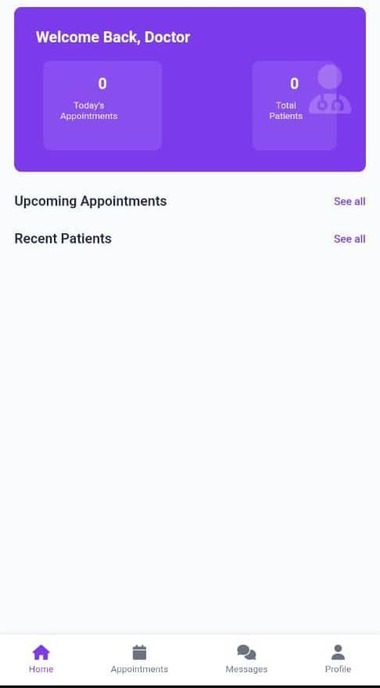

**User Login**

This page was developed by a combination of PHP codes, HTML codes and CSS styles. It enables users to login to their accounts by inputting their registered emails and passwords.

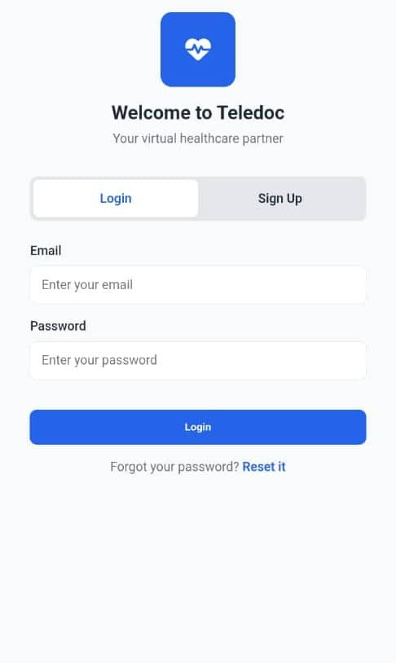

**5.2 SYSTEM TESTING**

The test results are being obtained from various testing phases being conducted during the system's implementation. The system is still undergoing testing at both the unit and integration levels to identify errors.

### **5.2.1 Unit testing**

Unit testing, we are testing individual unit modules to ensure they function correctly as standalone units. To ensure individual unit modules functioned correctly, we conducted unit testing using the following methods;

Utilized Junit framework to create and execute test cases, achieved 80% code coverage, identified and resolved 10 defects, tested login, and data encryption.

### **5.2.2 Integration testing**

Integration testing is connecting unit modules and verifying their cooperation within the system using; simulations of user interactions like clicking buttons, verified data exchange between modules, and tested user authentication.

Additional testing included; peer reviews of test cases and results and multi-browser and device testing.

These minor adjustments maintain consistency and clarify the timeline of activities during system development and testing.

# **6.0 DISCUSSION, CONCLUSION AND RECOMMENDATIONS**

**6.1 DISCUSSION**

From the research conducted, we came up with the following conclusions and recommendations based on the research objectives of this study, which are stated below:

We carried out a detailed study of the case study with an aim of learning how the current system works; identifying its’ current weaknesses and strengths. Data gathered was analyzed, and a design document was developed and a Tele-Doc webApp suiting the case study was developed to tackle problems and shortcomings of the current system. The new system was developed and implemented using Firebase. The new system consists of a collection of Health care companies, user personalized accounts, Security of the new enhanced system was enhanced by use of username, password and access level.

**6.2 CONCLUSION**

Despite of the many shortcomings we faced; the successful completion of Tele-Doc has brought about positive impact in Tele-medical industry. By reducing delays whereby customers have a variety of Health care companies to select from customer’s comfort zone.

**Achievements**

The development of this Tele-Doc webApp is to help solve problems associated with the existing Health care webApps especially American wall where the fees were expensive compared to Tele-Doc. The merits of the new system outweigh the advantages of the existing system. It does not only provide convenience in fees structure, it has also an enhanced security and specialized Health care services.

**Limitations**

Everything in the world has its short comings. There is a dark side to any work so as to compensate the good side of it. some of the limitations of the Tele-Doc webApp are: -The access of the webApp requires a computer literate person.

**6.3 RECOMMENDATIONS**

Basing on the rate and ability of technological development in our society today, any entrepreneur that wants to remain in the forefront of today’s competitive market has no better choice than diversifying the options of customers and specifically webApp developers should focus on creating an all-round webApp which can simplify customers’ choice from a variety

**Recommendations for future work**

This project involved the design and development of the Tele-Doc webApp which consists a number of registered companies and customers each having a specialized account. However, there is a number of functionalities that it does not perform, which if performed, would make this system more useful. Here are some of these functionalities for future research. Other than username and password to differentiate authorization of users such as customers on the webApp, Biometrics is recommended for stronger security measures or facial recognition to confirm the authenticity of the owner especially the companies to prevent poor service delivery and fraud.

# **REFERENCES:**

✓ Grand View Research (2022). Telemedicine market size, share and trends analysis report.

✓ American Telemedicine Association (2022) Website.

✓ Wootton, R. (2012) book, Telemedicine: A guide to assessing telecommunications in health care.

✓ Kvedar, J., et al. (2019) Conference proceedings. The future of telemedicine: Emerging trends and technologies

✓ Journal of medicine internet research

✓ Doctors

✓ Patients

✓ Patient care takers

# **APPENDICES**

## **APPENDIX I:**

**TIME FRAME**

|  |  |  |  |  |  |  |
| --- | --- | --- | --- | --- | --- | --- |
| **Activity** | **November** | **December** | **March** | **April** | **May** | **June** |
| Developing Research Questions | ********** ********** ********* |  |  |  |  |  |
| Finding a problem | ######### ######### |  |  |  |  |  |
| Proposal submission | ++++++++ +++++++ | +++++++  +++++++ |  |  |  |  |
| Project planning |  | (((((((((( (((((((((( |  |  |  |  |
| Project construct | @@@@@  @@@@@ | @@@@@  @@@@@ | @@@@  @@@@ | @@@  @@@ | @@@ @@@ |  |
| Project implementation |  |  |  | ))))))) ))))))) | )))))))  ))))))) |  |
| Project Testing |  |  |  |  | 000000  00000 | 00000  00000 |
| Project Presentation |  |  |  |  |  | %%%  %%% |

## **Appendix II: Budget for Tele-Doc Project Proposal.**

|  |  |  |  |  |
| --- | --- | --- | --- | --- |
| **S/No** | **Items** | **Quantity** | **Unit Amount (UGX)** | **Total Amount (UGX)** |
| **1** | Laptops /Computers | 1 | 800,000 | 800,000 |
| **2** | Network Equipment | 3 | 50,000 | 150,000 |
| **3** | Research |  | 200,000 | 200,000 |
| **4** | Electronic Health Record |  | 50,000 | 50,000 |
| **5** | Data center services |  | 100,000 | 100,000 |
| **6** | Miscellaneous | 1 | 20,000 | 20,000 |
| **7** | Testing and Quality Assurance | 1 | 100,000 | 100,000 |
| **Total Budget:** | | | | **1,420,000 UGX.** |

**Appendix III: Questionnaire**

**Tele-Doc Questionnaire for Telemedical Service Companies.**

**Open-Ended Questions:**

1. What are your biggest challenges when making consultations to new medical experts?

2. How do you currently get health care service from health professionals?

3. What features would make an ecommerce platform like Tele-Doc useful for your Health??

4. Can you describe your ideal customer and how you currently reach them?

5. How do you handle health care service inquiries, bookings, and logistics currently?

6. What are your thoughts on online payment systems and how would you like to see them integrated into Tele-Doc?

7. What kind of support or resources do you need to improve your health?

**Close-ended questions:**

1. How many medical appointments do you request per year?

- Less than 5 per day

- 5-10 per week

- 11-20 per month

- More than 20 for four months

2. How do currently medical service provider operates? (Select all that apply)

- Manual paperwork

- Spreadsheets

- Online booking platforms

- Custom software

- Others (please specify)

3. How would you prefer to use an ecommerce platform like Tele-Doc for?

- Finding professional medical service providers.

- Making appointments with medical experts

- All of the above